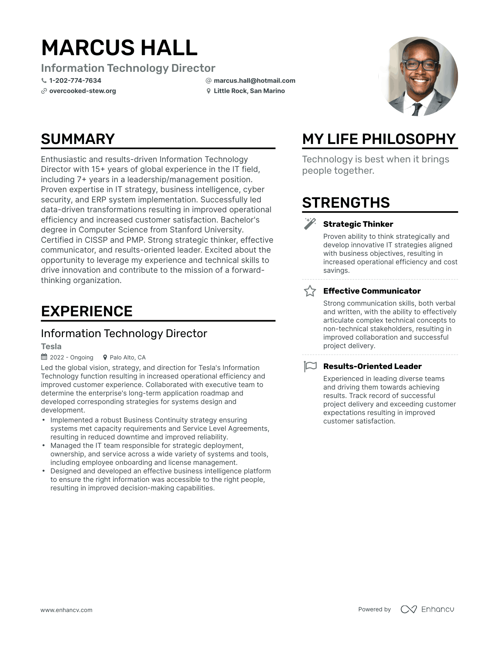
MARCUS HALL
Information Technology Director
1-202-774-7634 ✔overcooked-stew.org
@marcus.hall@hotmail.com Little Rock, San Marino
SUMMARY
Enthusiastic and results-driven Information Technology Director with 15+ years of global experience in the IT field, including 7+ years in a leadership/management position. Proven expertise in IT strategy, business intelligence, cyber security, and ERP system implementation. Successfully led data-driven transformations resulting in improved operational efficiency and increased customer satisfaction. Bachelor's degree in Computer Science from Stanford University. Certified in CISSP and PMP. Strong strategic thinker, effective communicator, and results-oriented leader. Excited about the opportunity to leverage my experience and technical skills to drive innovation and contribute to the mission of a forward- thinking organization.
EXPERIENCE
Information Technology Director
Tesla
2022 Ongoing
Palo Alto, CA
Led the global vision, strategy, and direction for Tesla's Information Technology function resulting in increased operational efficiency and improved customer experience. Collaborated with executive team to determine the enterprise's long-term application roadmap and developed corresponding strategies for systems design and development.
•
•
·
Implemented a robust Business Continuity strategy ensuring systems met capacity requirements and Service Level Agreements, resulting in reduced downtime and improved reliability.
Managed the IT team responsible for strategic deployment, ownership, and service across a wide variety of systems and tools, including employee onboarding and license management.
Designed and developed an effective business intelligence platform to ensure the right information was accessible to the right people, resulting in improved decision-making capabilities.
MY LIFE PHILOSOPHY
Technology is best when it brings people together.
STRENGTHS
++
Strategic Thinker
Proven ability to think strategically and develop innovative IT strategies aligned with business objectives, resulting in increased operational efficiency and cost savings.
Effective Communicator
Strong communication skills, both verbal and written, with the ability to effectively articulate complex technical concepts to non-technical stakeholders, resulting in improved collaboration and successful project delivery.
Results-Oriented Leader
Experienced in leading diverse teams and driving them towards achieving results. Track record of successful project delivery and exceeding customer expectations resulting in improved customer satisfaction.
www.enhancv.com
Powered by Enhancu

